**Random Forest**

**Example-Fraud Check Dataset**

'data.frame': 600 obs. of 6 variables:

$ Undergrad : Factor w/ 2 levels "NO","YES": 1 2 1 2 1 1 1 2 1 2 ...

$ Marital.Status : Factor w/ 3 levels "Divorced","Married",..: 3 1 2 3 2 1 1 3 3 1 ...

$ Taxable.Income : int 68833 33700 36925 50190 81002 33329 83357 62774 83519 98152 ...

$ City.Population: int 50047 134075 160205 193264 27533 116382 80890 131253 102481 155482 ...

$ Work.Experience: int 10 18 30 15 28 0 8 3 12 4 ...

$ Urban : Factor w/ 2 levels "NO","YES": 2 2 2 2 1 1 2 2 2 2 ...

**In the above data frame 3 variables are factors and rest all are numeric and target variable is Taxable.Income**

**Now we create another variable type, which is factor and contain desired results Good or Risky.**

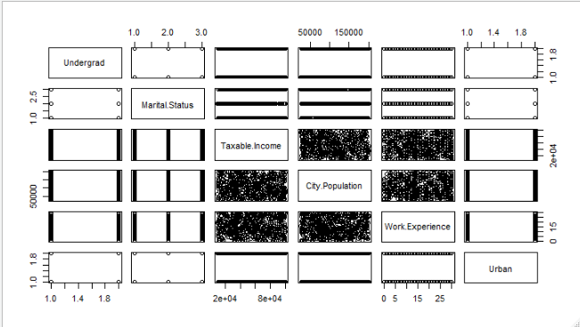

**From the pairs plot, none of variable is correlated with our target variable Taxable.Income and uniform distributed scatter plots between all the numeric variable.**

**Treatment With Imbalanced Data 🡺**

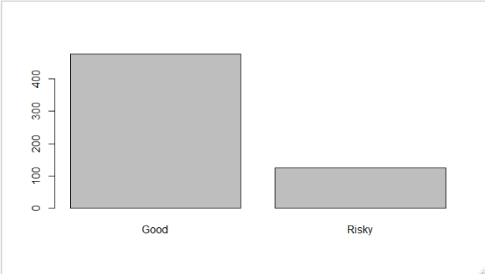

**Good Risky**

**476 124**

**From above plot, our target variable is imbalanced, so we will make ratio equal as 1.**

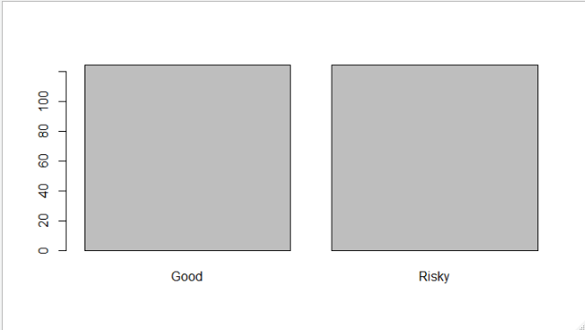

**Now our data is equal in ratio.**

**Model-1 🡺**

**Confusion Matrix**

Predicted

Actual Good Risky

Good 144 3

Risky 32 1

**Accuracy 🡺0.8055**

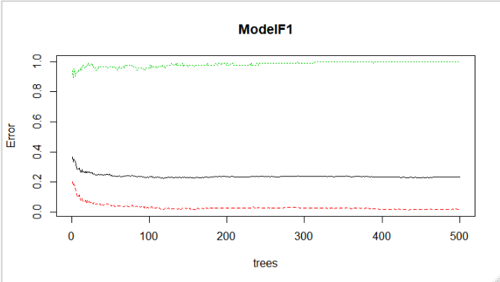

**Model-2 🡺**

**Confusion Matrix**

Predicted

Actual Good Risky

Good 131 16

Risky 32 1

**Accuracy 🡺0.7333**

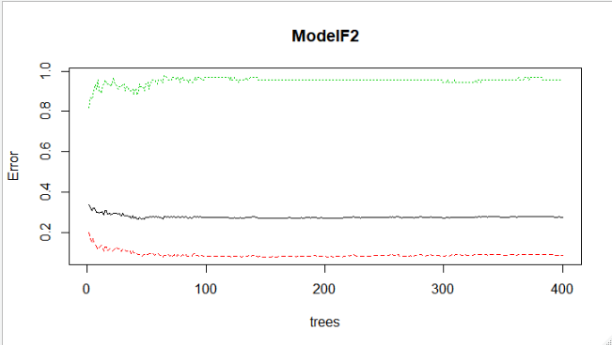

**Turing the Random Forest**

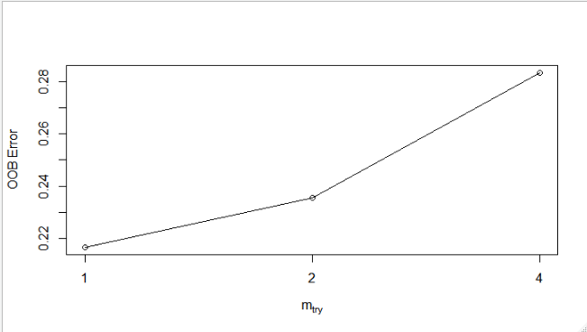

**Model-3 🡺**

**Confusion Matrix**

Predicted

Actual Good Risky

Good 147 0

Risky 33 0

**Accuracy 🡺0.8166**

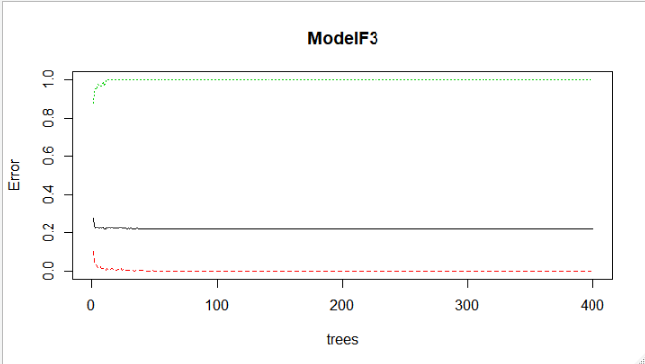

**From above information we can infer that Model-3 is good model**

**with accuracy 81.66%.**